**CURRICULUM VITAE**

**PERSONAL DATA**

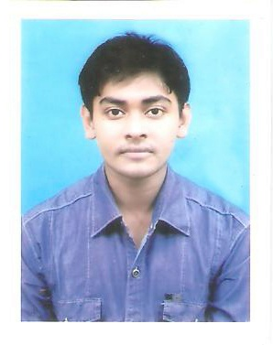**Name:** BISHAL BISWAS

**Website**: [itsme-bishal.blogspot.com](https://itsme-bishal.blogspot.com/)

**Date of Birth:** 04/07/1996(25 years)

**Address:** 436 B/2, Minz Villa, Daspara Road, Opposite Banker Maath, Thakurpukur, Tollygunge, Kol 700063

**Phone:** 96799 62953

**Email:** [BishalAnshu@yahoo.in](mailto:BishalAnshu@yahoo.in)

**OBJECTIVE**

Pursuing opportunity which will allow me to grow professionally while effectively utilizing my skills set to contribute in developing and working for the nation.

**EDUCATION DETAILS**

|  |  |  |  |
| --- | --- | --- | --- |
| **QUALIFICATION** | **BOARD** | **PERCENTAGE** | **PASSING YEAR** |
| Secondary | CBSE | 68.4% | 2013 |
| Higher Secondary | NIOS | 59.17% | 2015 |
| Degree Course on Software Engineering | Brainware | 70% | 2016 |
| Graduation **(BCA)** | IGNOU | 72.27%  [[Grade Card](https://gradecard.ignou.ac.in/gradecardM/Result.asp?eno=170533087&program=BCA&hidden_submit=OK=)] | 2017-2021 |
| Post Graduation **(MCA)** | IGNOU | 6th Semester Running | 2021-Present |

**COMPUTER RELATED KNOWLEDGE**

|  |  |  |
| --- | --- | --- |
| C Programming | C++ | Java |
| JSP(Servlet) | Linux | Microsoft Office |
| VB.Net | ASP.Net(C#/Sharp) | Microsoft SQL Server |
| Adobe Photoshop | HTML, CSS | JavaScript |

**EXPERTISE/WORK**

1. Web Designing (HTML, CSS) – 1.5 years experience.
2. My own portfolio site is fully designed by me. [[visit](https://bishal-biswas.github.io/site)]

**LANGUAGES KNOWN:**

**Read, Write, And Speak:** English, Hindi, and Bengali**.**

***Declaration: All the above information is true to the best of my knowledge.***